
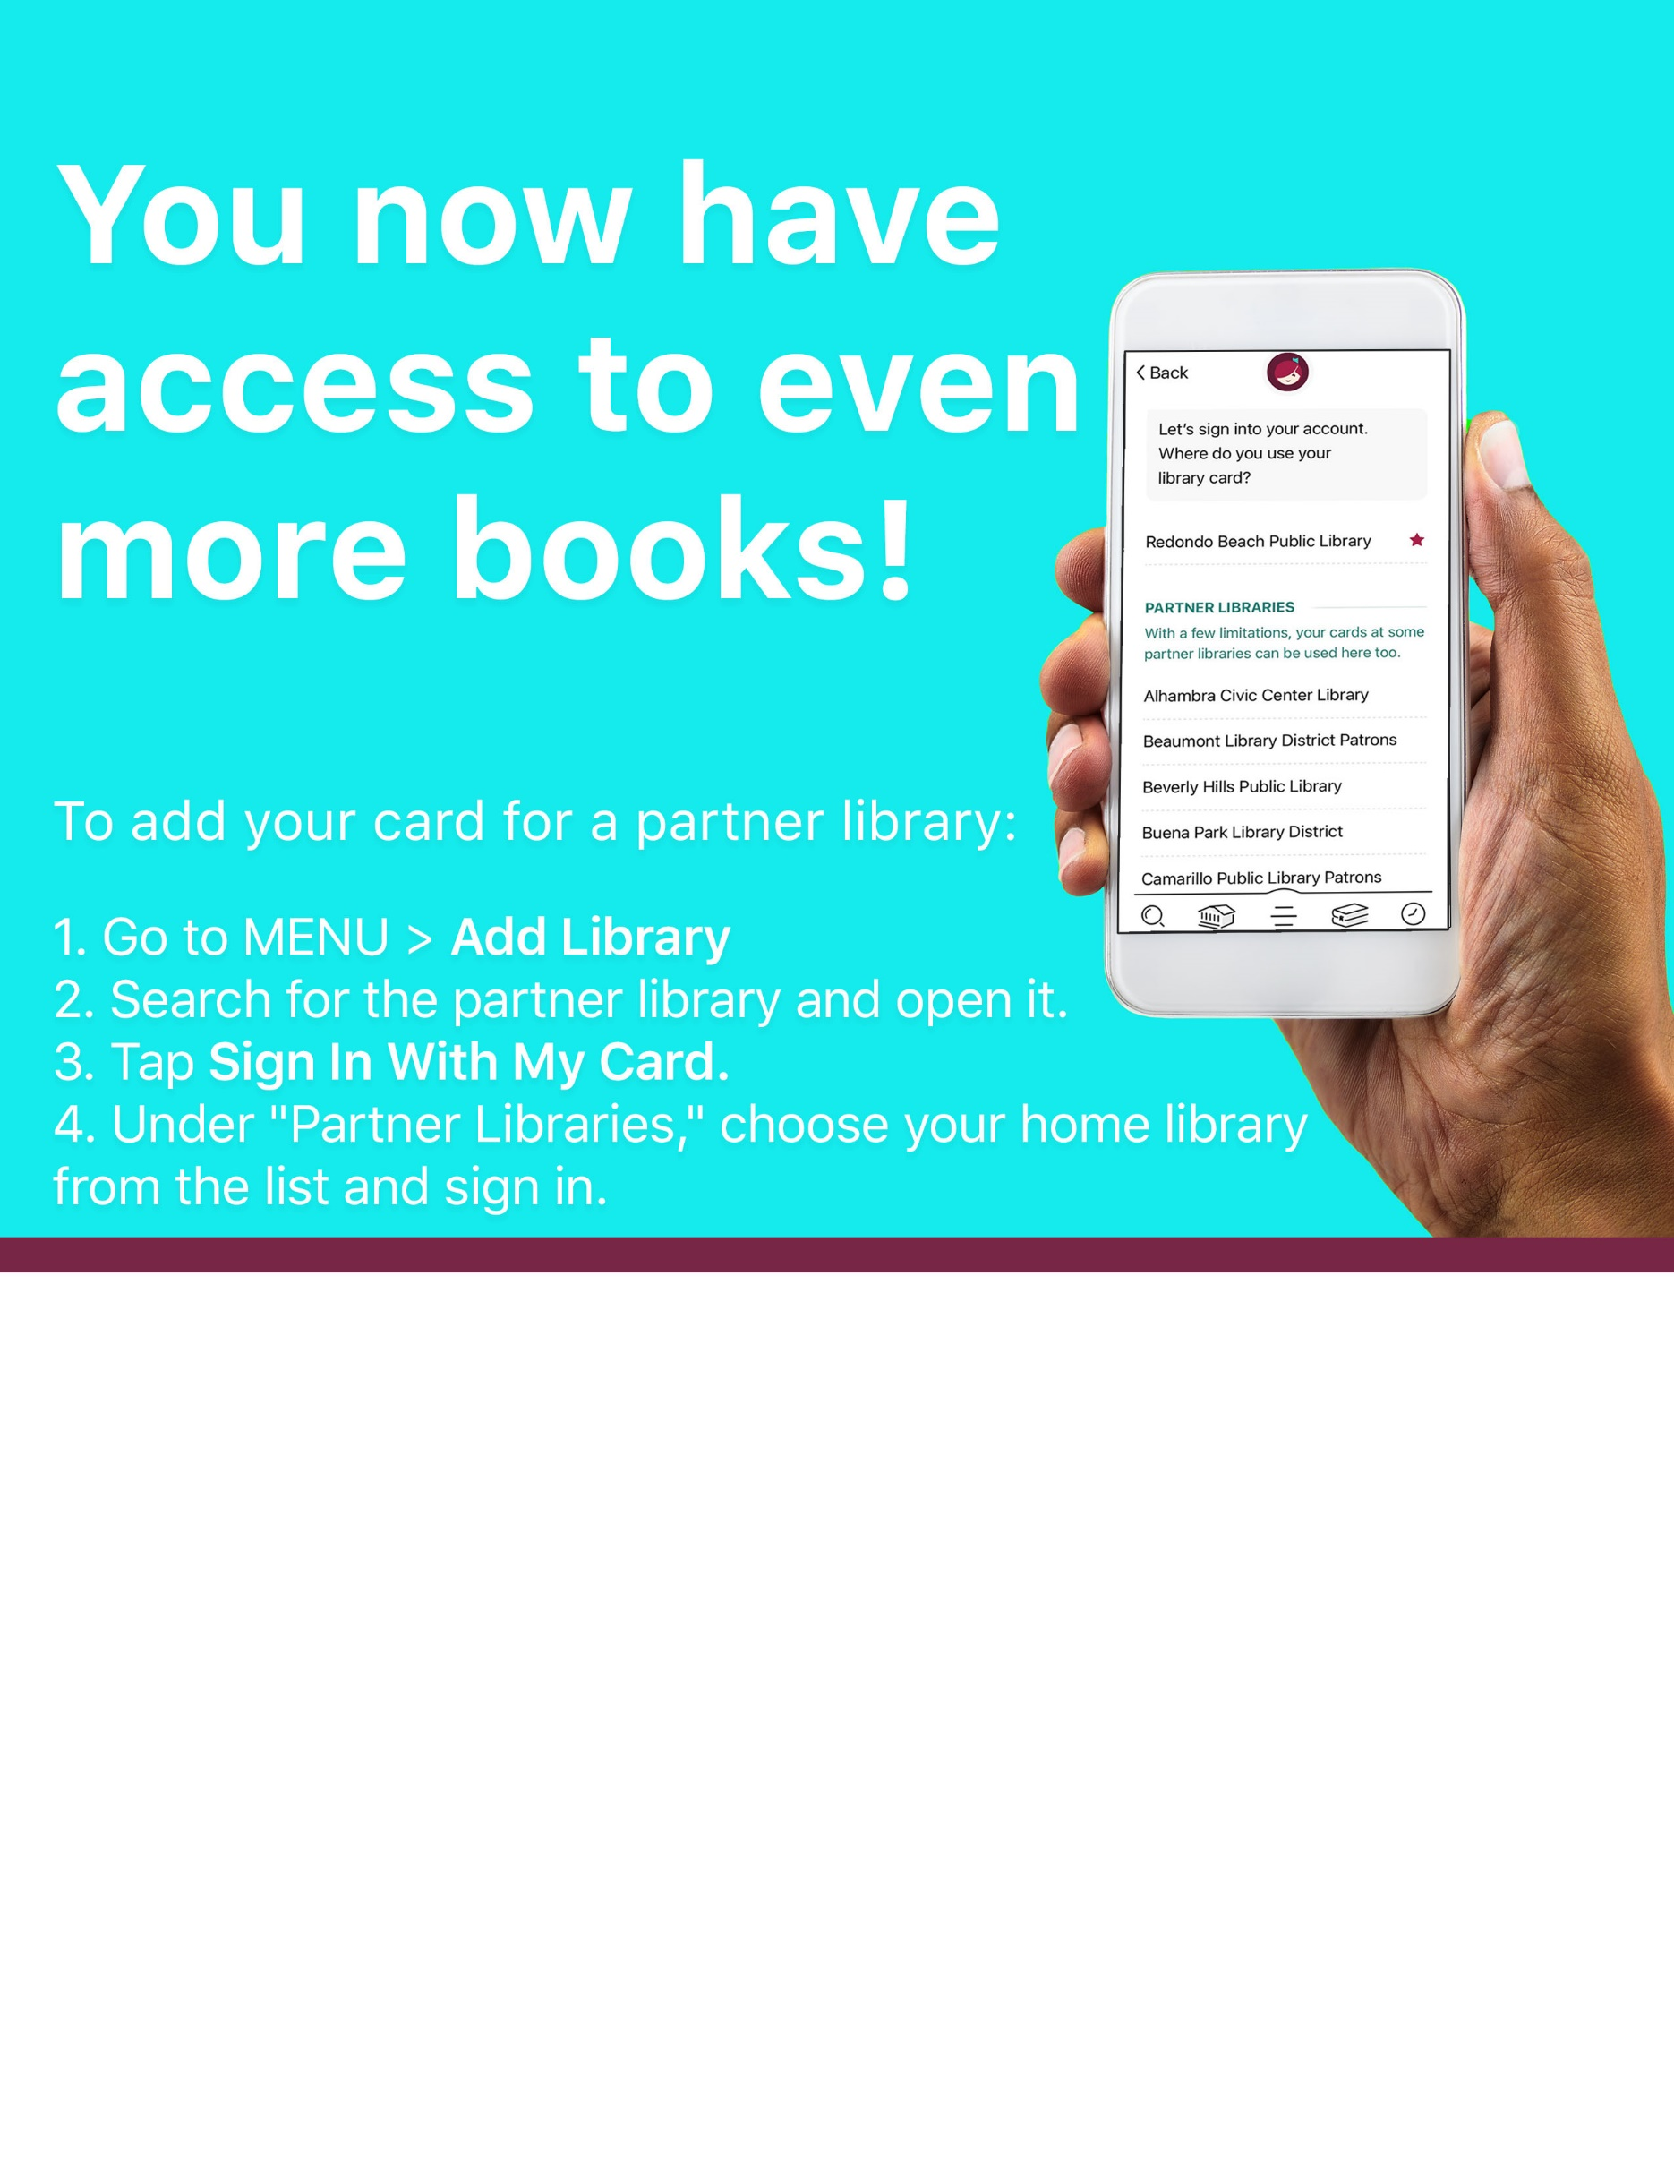
Get more access with your [enter library name] library card!
You can now borrow titles in Libby from Mohawk Valley Library System, Southern Adirondack Library System, and Upper Hudson Library System.

